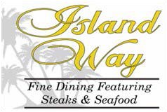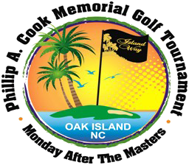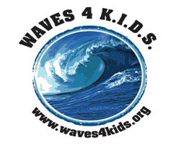

Phillip A. Cook Memorial Golf Tournament
A Benefit for WAVES 4 K.I.D.S. of Brunswick Co.
In a world where your appearance and possessions are immediately used as judgment labels, imagine not having the necessary supplies to be successful in school. Imagine being embarrassed by the condition of your shoes, so you don’t want to go to school. Imagine having parents that are not aware of how you feel or simply do not care.

The goal of WAVES 4 K.I.D.S is to provide financial support and create services to satisfy unmet needs of youth associated with Foster care and Child Protective Services in Brunswick County. WAVES works with the Department of Social Services, and Guardian Ad Litem and other organizations located in Brunswick County, NC. WAVES provides for those needs that are not funded by any other private or government organization/agency.

Register for the tournament: www.waves4kids.org
Donate today: Visit us at www.waves4kids.org

Your participation in the Phillip A Cook Memorial Golf Tournament ensures the continuation of WAVES’ successful programs, including the Phillip A. Cook Education and Development Fund, which provides extended educational funds for college and vocational or trade schools.

PO Box 162 Bolivia, NC 28422
WAVES 4 KIDS is a 501(c)3 nonprofit organization, Federal Tax ID# 06-1732907, NC License # SL008027 Financial information about this organization and a copy of its license are available from the State Solicitation Licensing Branch at 919-807-2214. The license in not an endorsement by the State.

